Pizza with Onions, Mushrooms & Brie

6 Tbs. olive oil, plus more as needed
4 large onions, halved and thinly sliced
2Tbs. fresh rosemary, minced
Coarse kosher salt and freshly ground pepper
1/2 cup dry white wine
1 lb. oyster, chanterelle, shiitake or cremini mushrooms, sliced
1 large shallot, minced
2 Tbs. minced fresh flat-leaf parsley, plus more for garnish
Cornmeal for dusting
2 rounds pizza dough
1 lb. Brie cheese, cut into small pieces

Preheat the oven to 425 degrees F. In a large nonstick frying pan over medium heat, warm 1 1/2 tablespoons of the oil. Add the onions and rosemary. Sprinkle with salt and pepper, and saute until golden, about 20 minutes. Add the wine and simmer until evaporated, about 1 minute. Transfer the onions to a bowl. Wipe out the frying pan, set over medium-high heat, and warm the remaining 1 1/2 tablespoons oil. Add the mushrooms and shallot. Season with salt and pepper. Saute until the mushrooms are tender and juices evaporate, about 5 minutes. Remove from the heat. Mix in 1 tablespoon parsley.
Brush a large baking sheet with oil and sprinkle with cornmeal. On a lightly floured surface, roll out each piece of the dough to a round 10-11 inches in diameter. Transfer the crust to the baking sheet. Brush the crust with oil. Spread the onions and then the mushrooms over the crust, leaving a border. Sprinkle with cheese. Bake until the crust browns and the cheese melts, 12-15 minutes.
Transfer the pizza to a cutting board. Cut into wedges. Sprinkle with parsley and serve right away. Makes 2 pizzas; serves 8.

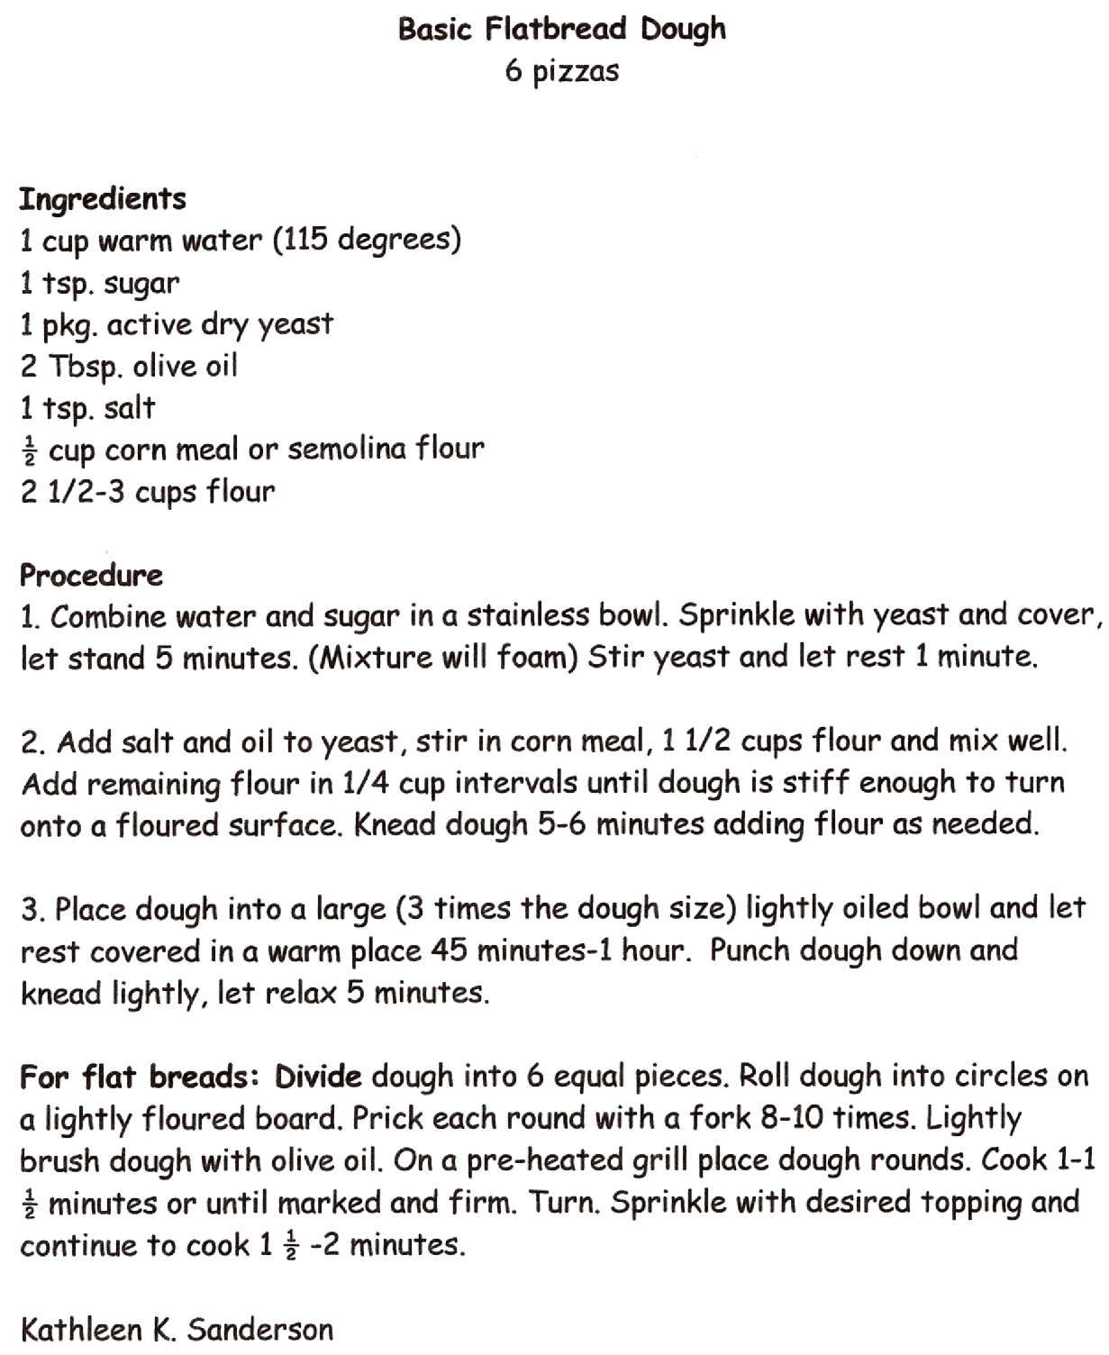

Mixed greens with Roasted Beets and Candied Pecans
8 servings

Ingredients

4 golden beets ( each about the size of an apple)
1 cup pecans
1/3 cup sugar
3 tbsp butter
Salt and pepper to taste
2/3 cup balsamic vinegar
1 Tbsp. Dijon mustard
1/4 cup vinegar, red or white wine, sherry or balsamic
½ cup extra virgin olive oil
¼ cup canola oil
8-10 cups assorted greens and herbs (frisse, arugula, endive, mesclune)
8 oz crumbled blue, goats or feta cheese.

Procedure
Preheat oven to 400°F.
Wrap the beets in foil, and roast in the oven for 45 minutes to 1 hour, or until they can be pierced easily with a knife. Cool slightly, and peel. Then slice, and set aside.
Place the pecans into a nonstick saucepan with the sugar and the butter. Stir to dissolve the sugar, and bring to a boil. Reduce the heat to a simmer and cook for about 5-7 minutes, or until golden and almost dry. Season with salt and pepper to taste.
Mix together mustard and vinegar. Whisk in the oils. Adjust seasoning, and set aside until ready to serve. Toss the dressing with the greens, and plate.
Transfer the sliced beets and pecans to the salad plate over the greens. Sprinkle with cheese, and serve immediately.

SOUS VIDE STEAK RECIPE
1 steak, about 1 ½” thick, choose your favorite cut
1 Tbsp olive oil
Salt/ Black pepper
1 bay leaf
2 small garlic cloves crushed
Fresh thyme, or other seasonings and herbs you like
1 gallon-size freezer bag

INSTRUCTIONS
- Start your water bath with hot water from your tap. Set your sous vide cooker temperature 2-3 degrees lower than your target meat doneness temp. 125 for rare, 130 for medium rare
- Add the oil to the bag.
- Liberally salt and pepper the steak and add desired herbs.
When your water bath has come to temp, carefully lower your steak in its bag into the water, pressing on the bag to further expel air from it. A wooden spoon can be useful for this if the water is too hot for you.
- Clip the bag to the edge of the pot and set your desired temperature. Allow the steak to cook. Most 2-3-inch steaks will take 1 ½-2 hours
- As the meat nears its target temperature, prepare an ice bath of equal parts ice and water.
- When your machines alarm sounds, remove your steak bag from the cooker and plunge it into the ice bath. Let it sit for at least 1-2 minutes to allow the exterior to cool.
- To Cook
- As you remove the steak from the bag, pick off any whole herbs that may cling to the surface, and put it into the hot skillet. Increase heat to high.
Let the steak sear for 1 minute or until a good chocolate brown is achieved. Flip the steak and sear another 1 minute. If you are preparing multiple steaks, do not crowd the pan! Base how many steaks you sear at a time on the size of your pan and the size of your steaks. When a good crust has formed on both sides, remove your steak from the pan and let your steak rest for 5 minutes. Meanwhile make a pan sauce in the sauté pan.

Sriracha Butter

1/2 cup (1 stick) unsalted butter, at room temperature
2 tablespoons Sriracha
1 clove garlic, minced
1 tablespoon chopped fresh flat-leaf parsley

Using a wooden spoon or in the bowl of a stand mixer equipped with a paddle attachment, blend the butter with the Sriracha, garlic, and parsley until completely combined.

Scoop the butter onto a sheet of plastic wrap or parchment paper.. Roll the plastic around the butter, forming a log about 1 inch in diameter. Wrap up tightly.

Chill in the refrigerator for at least an hour. Once hard, the butter may be sliced and served on meat, sweet potatoes, corn-on-the-cob or tossed into hot pasta or rice. The butter keeps in the refrigerator for up to 2 weeks or in the freezer for 6 months.

Roasted Yukon Gold Potato Salad
Serves 6
Yukon Gold potatoes are known for their golden, buttery color. This recipe combines crispy roasted potatoes with a sweet and savory vinaigrette. Tossing the potatoes with the dressing while they are still warm helps them absorb the flavor. Crunchy bacon, fresh tomatoes and green onions add flavor, color and texture, creating a lively variation on traditional potato salad.

2 pounds Yukon Gold potatoes
6 tablespoons extra-virgin olive oil, divided
2 teaspoonskosher salt, plus additional as needed
1 teaspoon freshly ground black pepper, plus additional as needed
12 thick slices bacon, diced
2 teaspoons Dijon mustard
2 (packed) tablespoons light brown sugar
¼ cup balsamic vinegar
8 whole green onions, thinly sliced
2 cups ripe yet firm cherry or grape tomatoes, halved ( or quartered if large)
3 tablespoons chopped fresh flat-leaf parsley
2 tablespoons thinly sliced fresh chives

Preheat the oven to 450°F.
1.Wash and dry the potatoes. Cut into 1-inch cubes, and toss in a medium bowl with 2-3
tablespoon of the olive oil, 1 teaspoon salt and ½ teaspoon black pepper.

2.Carefully arrange the potatoes in a single layer on the preheated pans. Return the pans to the oven, and roast until the potatoes are golden brown and tender when pierced with a skewer or the tip of a small knife, about 25 minutes.

3.While the potatoes are cooking, place the bacon in a medium sauté pan over medium-high heat; cook until crisp. Use a slotted spoon to transfer the bacon to a paper towel-lined plate to drain. Reserve 2 tablespoons of the bacon drippings for the dressing.

4.In a small bowl, whisk together the Dijon mustard, brown sugar and balsamic vinegar.
Whisk in the remaining 2 tablespoons of olive oil and the 2 tablespoons of reserved bacon drippings. Season to taste with salt and pepper; set aside until needed.

5.Transfer the warm roasted potatoes to a medium serving bowl. Add the green onions,
tomatoes, parsley, chives and bacon. Add just enough vinaigrette to moisten the salad, and toss gently to coat. Season to taste with salt and pepper. Serve at room temperature.

Sauteed Kale with garlic and sweet butter
Serves 4

4 tablespoons unsalted butter
3 cloves garlic, peeled and sliced
1 large bunch kale, stems removed and leaves coarsely chopped
½ cup vegetable stock, white wine or water
Salt, pepper and red pepper flakes to taste
2 tablespoons red wine vinegar
4 ounces thinly sliced and julienned prosciutto, optional

- Heat butter in a large sauté pan over medium-high heat until it shimmers. Add the garlic and cook until soft.
- Add kale to the pan, turn the heat to high and add the stock. Use a spoon or tongs to toss the greens in the oil and the stock, then cover for approximately 5-7 minutes or until soft and wilted, but still quite green. Season with the salt, peppers and vinegar, and if using, add the prosciutto, tossing to combine, and cooking an additional 1-2 minutes.

BLUE CHEESE CRUSTED TOMATOES
Yield: 6 servings

Ingredients
3 ripe tomatoes or 6 plum tomatoes
Salt and ground black pepper, to taste
Extra-virgin olive oil
1/3 cup chopped fresh Italian parsley
1/4 cup freshly crumbled blue cheese or gorgonzola
¼ cup panko crumbs

Method
Pre-heat oven 400°F.
Cut round tomatoes in half CROSSWISE and plum tomatoes in half LENGTHWISE (slice a small amount off to even bottoms of tomatoes to prevent them from rolling in the pan). Place in a shallow oven-to-table baking dish and sprinkle with salt and pepper. Drizzle each half with olive oil.

In a small bowl, mix together parsley, panko and cheese. Sprinkle evenly over tops of the tomatoes. Place in the oven and bake 15 to 18 minutes. Allow tomatoes to stand several minutes before serving.

Devils Food Cake with Chocolate Buttercream Frosting

Ingredients
- 2 cups sugar
- 1-3/4 cups all-purpose flour
- 3/4 cup unsweetened Cocoa
- 2 teaspoons baking soda
- 1 teaspoon baking powder
- 1 teaspoon salt
- 2 eggs
- 1 cup buttermilk or sour milk*
- 1 cup strong black coffee OR 2 teaspoons powdered instant coffee plus 1 cup boiling water
- 1/2 cup vegetable oil
- 1 teaspoon vanilla extract

Directions
Heat oven to 350°F. Grease and flour 12-cup fluted tube pan, two 9-inch round baking pans or one 13x9x2-inch baking pan.

Stir together sugar, flour, cocoa, baking soda, baking powder and salt in large bowl. Add eggs, buttermilk, coffee, oil and vanilla; beat on medium speed of mixer 2 minutes (Batter will be thin). Pour batter evenly into prepared pan.

Bake 50 to 55 minutes for fluted tube pan, 30 to 35 minutes for round pans, 35 to 40 minutes for rectangular pan or until wooden pick inserted in center comes out clean. Cool 10 minutes. Loosen cake from side of pan and remove from pans to wire racks. Cool completely. Frost as desired. Yields 10 to 12 servings.
* To sour milk: Use 1 tablespoon white vinegar plus milk to equal 1 cup.

Chocolate Buttercream Frosting
Makes: 3 cups

A simple recipe for classic chocolate buttercream frosting. Perfect for frosting cakes, cookies, brownies, or cupcakes.
Ingredients
- 1 cup unsalted butter (2 sticks or ½ pound), softened (but not melted!)
- 3½ cups confectioners (powdered) sugar
- ½ cup cocoa powder
- ½ teaspoon table salt
- 2 teaspoons vanilla extract or 1 teaspoon almond extract
- 4 tablespoons milk or heavy cream
Instructions
- Cream butter for a few minutes in a mixer with the paddle attachment on medium speed. Turn off the mixer. Sift 3 cups powdered sugar and cocoa into the mixing bowl. Turn your mixer on the lowest speed (so the dry ingredients do not blow everywhere) until the sugar and cocoa are absorbed by the butter. Increase mixer speed to medium and add vanilla extract, salt, and milk/cream and beat for 3 minutes. If your frosting needs a more stiff consistency, add a little more sugar. If your frosting needs to be thinned out, add additional milk 1 tablespoon at a time.

Note: to make a vanilla buttercream, omit the cocoa powder and increase the vanilla extract to 1 tablespoon.

